In 2011 a small group of individuals came together determined to create an enjoyable and healthy event during the Yorktown Fourth of July Celebration. Seven years later with your help, we are happy to say that we have created East Central Indiana’s best family fitness event. In concert with The Town of Yorktown and The Yorktown Chamber of Commerce the “Four for the Fourth” Run/Walk and 1 mile Fun Run is reaching new participants and helping the community move forward.
The Four for the Fourth could not have happened without the generous support of the sponsors who helped get the event off the ground, and those that have continued to sponsor and participate over the past 6 years. Each year we as a community see the tangible benefit of new trail construction happening and the sponsors of this event are hug part of that success. We are planning a number of new offerings this year and they will only be possible with your help.
We are approaching you today to see if you are willing to participate as a sponsor for the 2017 Four for the Fourth. We have set up 4 levels of sponsorship, each with unique publicity and entry opportunities:
- Bronze level sponsorship, $200…Will include your company name on any printed material, sponsorship posters/signs to be posted at the race and throughout the community, and two (2) free entries in the “Four for the 4th” Run.
- Silver level sponsorship, $500…Will include your company name on any printed material, sponsorship posters/signs to be posted at the race and throughout the community, your name printed along with all level 2 sponsors on the lower half of the race t-shirt, and five (5) free entries in the “Four for the 4th” Run.
- Gold level sponsorship, $750…Will include your company name on any printed material, sponsorship posters/signs to be posted at the race and throughout the community, your name and logo printed along with all level 3 sponsors on the top half of the race t-shirt, and ten (10) free entries in the “Four for the 4th” Run.
- Platinum level sponsorship, $1500…Will include special packet pickup and race day advertising along with opportunities for additional branding on associated race gear and advertising. Included will be 12 (12) free entries in the “Four for the 4th” Run. This level is limited to 3 companies/entities.
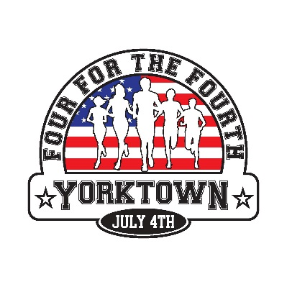
Thank you for taking the time to consider a sponsorship. If you have any additional questions please feel free to contact any of the committee members. We appreciate your support and hope that you will consider sponsoring the event.
Respectfully, “Four for the 4th” Run Committee
Norm Aul Chris Day Ted Johnson
Pete Olson Bob Ratchford Christy Baker
Kristi Geidel Dustin Woods John Mickle
Ryan Groves Ryan Gernand

